**CS423**

**Assignment 2**

**DEVELOPMENT OPERATIONS**



**Group:**

**Muhammad Musa 2020330**

**Basil Shaqeeq 2020901**

**Introduction:**

The project at hand involves the automation of the software development process, spanning from local development to deployment on various environments. The primary objective is to streamline and enhance the workflow using DevOps practices. The goal is to streamline the deployment process and ensure that the application is always up-to-date and accessible to users.

**Assignment Objectives:**

The objective of this assignment is to:

* Clone a simple open source React application from GitHub.
* Deploy the application to a local machine.
* Create two EC2 instances on AWS for Testing and Staging environments.
* Configure automated deployment workflows in GitHub Actions.
* Test the automated deployment process.

**Deployment Challenges:**

* Setting up the environment on AWS, including creating EC2 instances, configuring security groups, and installing dependencies.
* Configuring the GitHub Actions workflows to perform the desired tasks, including building the application, running tests, and deploying to the appropriate environment.
* Debugging errors that occurred during the deployment process.

**Task 1:**

**Subtask 1: Cloning repo**

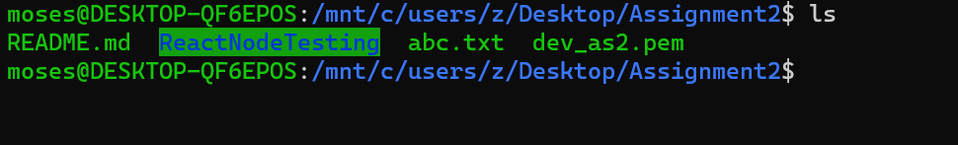

**Subtask 2: Deploying Application**

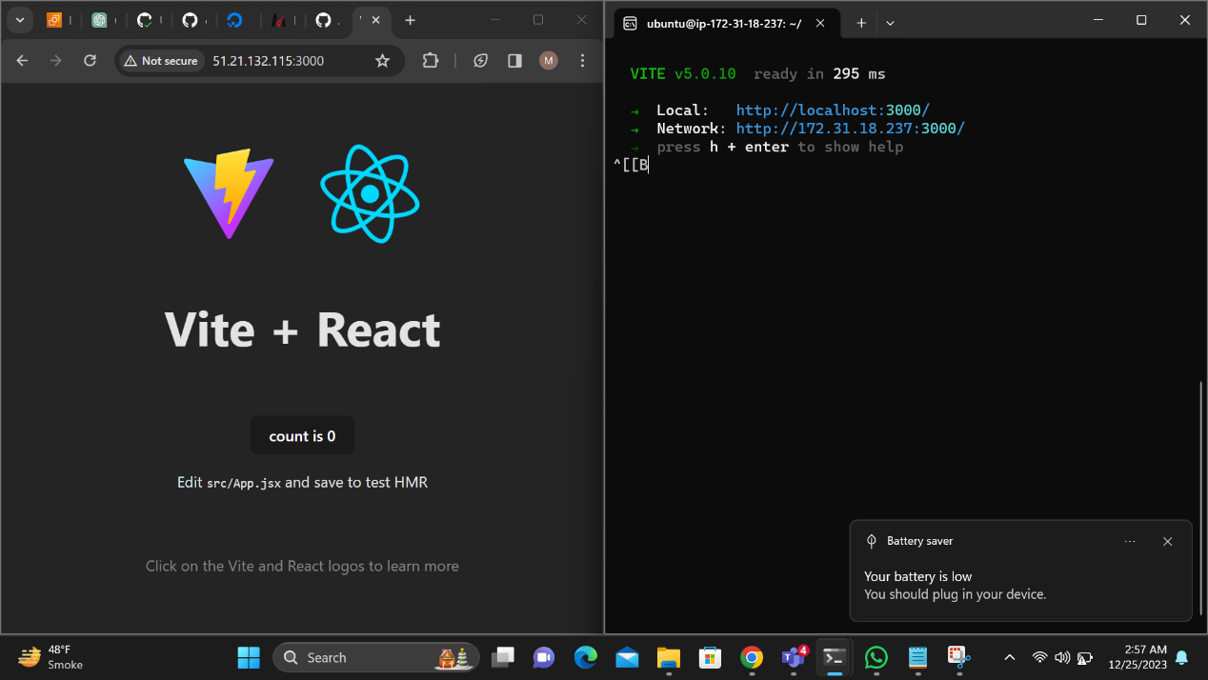

**Subtask 5: Main Branch Protection**

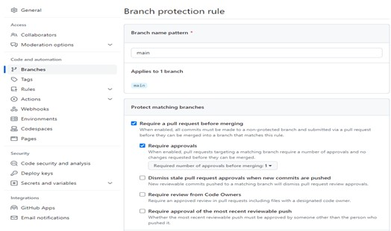

**Task 2:**

**Subtask: Creating EC2 Instance with described rules**

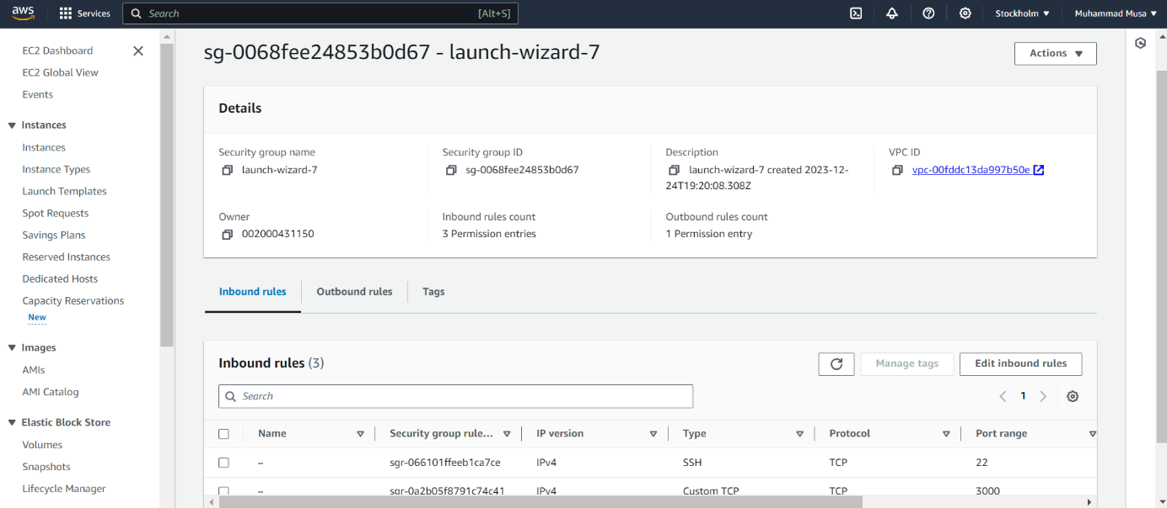

**Subtask: Installing Dependencies**

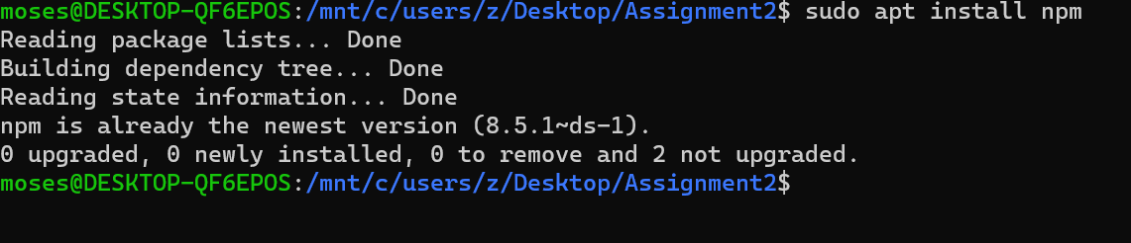

**Task 3:**

**Subtask 1: Testing Workflow**

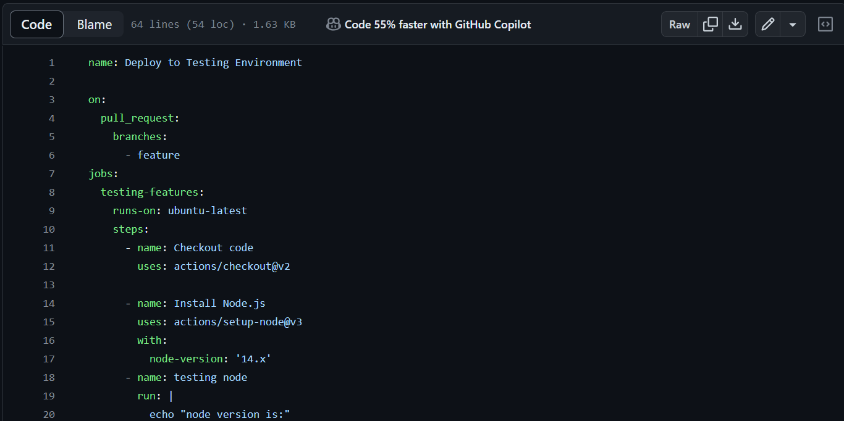

**Subtask 2: Staging Workflow**

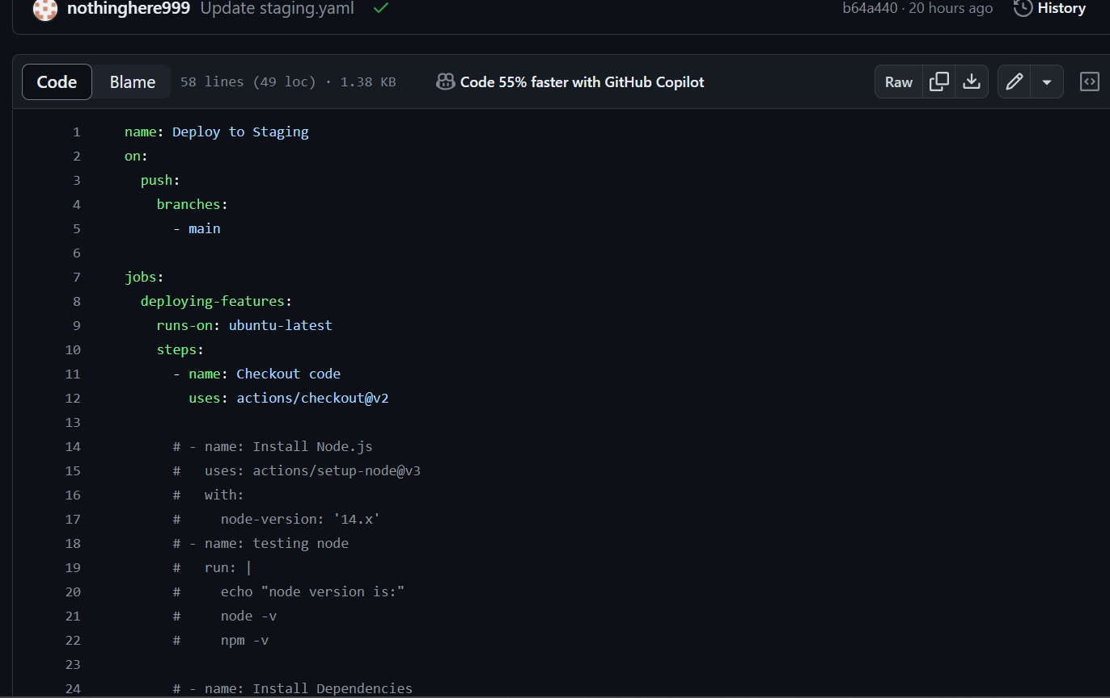

**Subtask 3 & 4:**

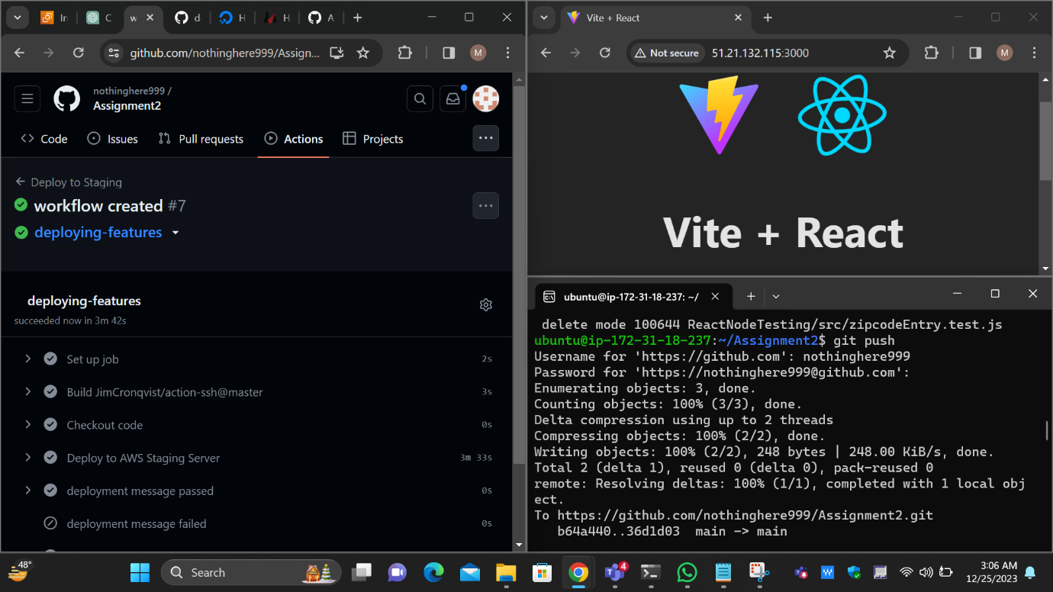

**Conclusion:**

This project successfully automated the deployment of a React NodeJS application from development to staging and production environments. The automated deployment process ensures that the application is always up-to-date and accessible to users. The project also provided valuable experience in setting up and configuring AWS services and GitHub Actions workflows.

**GitHub Link:**

https://github.com/nothinghere999/Assignment2

**Website Link:**

<http://51.21.132.115:3000/>